- Write a prolog program to describe the Family relations.
- Your prolog fact base should only contain information that defines parent-child or husband-wife relationship between two person
- You should write rules to describe the following Family relations.
  - father, mother, son, daughter, brother, sister, grandfather, grandmother, aunt, uncle
  - father/mother-in-law, brother/sister-in-law
  - Step father/mother, step son/daughter.
2.
- Write a Prolog database which describes 10 of your favorite books as funny, sad, science fiction etc. Add rules which select books based on your mood.
- Add daily weather information from last week to your database on books. Also add rules which describe your mood based on the weather conditions for a given day.
- Finally Test your rules by trying writing several queries which select books based the weather daily conditions.
- Possible value for mood: very happy, happy, sad, very sad etc.
Possible values for weather condition: hot, sunny, cloudy, cold, freezing etc.

3.
In a jungle, there inhabits the following animals: monkey, elephant, donkey, horse and dog.
About the animals we know only the following facts
- Elephant is bigger than horse
- Horse is bigger than donkey
- Donkey is bigger than dog
- Donkey is bigger than monkey

With only these facts available write rule to prove that – elephant is greater that donkey.
4.
Given the clauses/rules
- Marcus was a man.
- Marcus was a Pompeian.
- All Pompeian were Romans.
- Caesar was a ruler.
- All Pompeian were either loyal to Caesar or hated him.
- Everyone is loyal to someone.
- People only try to assassinate rulers they are not loyal to.
- Marcus tried to assassinate Caesar.
Express above facts/rules in prolog and try to answer whether Marcus tried to assassinate Caesar.
5.
Given a connected graph. Where 1, 2…..5 are vertices and connecting lines are edges.
- List the edges as facts like
  - Edge (1, 2).
  - Edge (3, 5). etc.
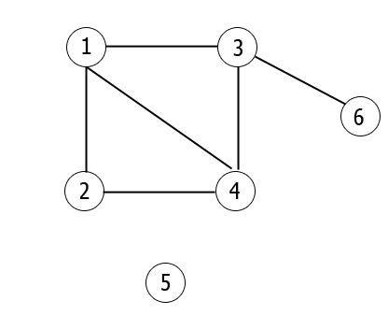
- Write prolog rule to find if two vertices are connected
- Find all paths between any two vertices.
6.
Using Dynamic database
Write a prolog program using dynamic to simulate medical diagnostic system for childhood diseases with implementing the following features:-
- Input the patient name, age, address, you have to use database to store user information.
- Your patient’s age should be below 12.
- The system should ask user about their symptoms. Based on these symptoms the systems will diagnosis user’s disease.
- You have to develop entire program interactive menu based to operate easily.
- You have to generate a report for patient after diagnostic.
- You may store patient’s information in individual data file.
- To operate the system one must provide user name and password to get access.
7.
Write a recursive rule in prolog which will take a number N as input and print the following sequences
- 1 2 3 4 ……. Up to N
- 1 3 5 7 ……. Up to N
- 2 4 6 8 ……. Up to N
8.
- Write a recursive rule in prolog which will take a number N and compute the factorial of N
- Write a recursive rule in prolog which will take a number N and print the first N Fibonacci numbers.
9.
Write a recursive rule in prolog which will take a number N as input and print the sum of the following
- 1+ 2 + 3 + 4 ……. Up to N
- 1 + 3 + 5 + 7 ……. Up to N
- 2 + 4 + 6 + 8 ……. Up to N
10. write a recursive rule in prolog which will take a number N as input and print the sum of the N random numbers between 1 to 100 (or between any arbitrary value A and B).
11.
Write prolog program for manipulating list in prolog. Such as.
- Appending
- Reversing
- Searching
12. Write program in C/C++/ Java to simulate various operations on fuzzy set such as
- Union
- Intersection
- Compliment
Not in list
13. Write prolog program for sorting int list in prolog.
14. Write prolog program for count list
15. Nth element of list.
16. Last element of list
17. Write a predicate to return the maximum value of X and Y.
18. Sum of N number
19. Min and max from 3 numbers
20. Print odd number from Lower limit to Upper limit
21. Print even number from Lower limit to Upper limit
22. Log on only 3 times try

